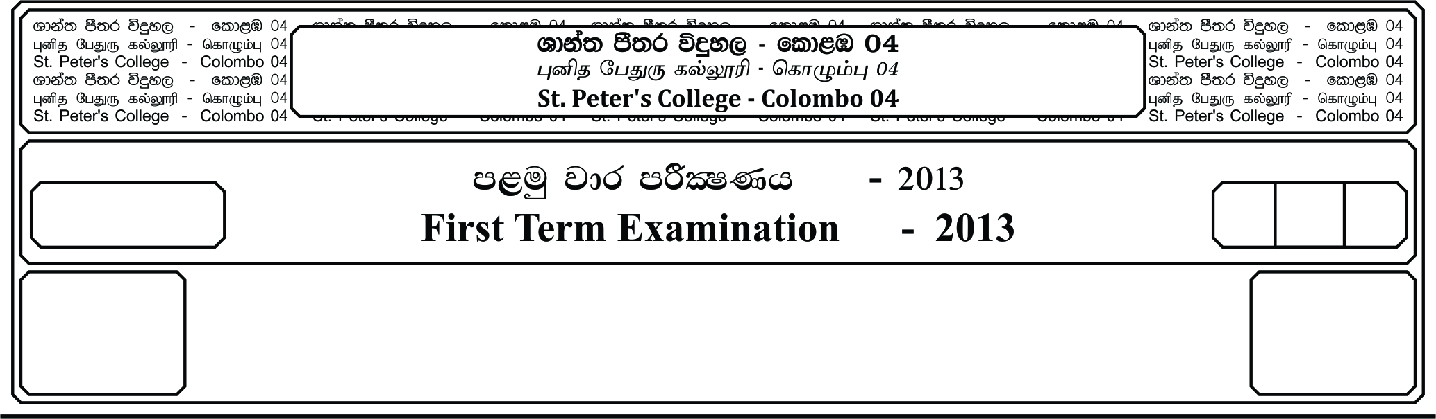

E

**idudkH bx.%Sis -** I

**English – I**

**m<uq jdr mÍCIKh - 2019**

**Third Term Examination - 2019**

meh 01

01 Hour

13 fY%aKsh

GRADE 13

I

**01. Complete the blanks by inserting the correct prepositions.**

about by from into to with

Many people today are worried ______________ drugs. Its seems that more and more people are getting addicted ______________ dangerous substance, such as heroine, crack and cocaine. This damages their health. But what leads ______________ people becoming drug addicts? Why do people inject drugs ______________ their veins? In some cases it is the inability to cope ______________ problems they may have in their everyday lives. When we complain ______________ the problems that hard drugs cause, we need ______________ remember that people suffer ______________ all kinds of health problems caused ______________ legal substances, like alcohol and cigarettes. We would all benefit ______________ more education and the government should attempt ______________ make sure that we know all the risks involved.

**(05 Marks)**

**02. Fill the blanks with the correct from of the verb.**

i. I wish you ______________ checking mu e–mails. You’re invading my Privacy.

will stop

have stopped

would stop

ii. My grand parent’s house ______________ pulled down just before I was born

had

had been

was

must have

iii. This time next month, I ______________ on a beach in Florida.

will lie

am lying

lie

I’ll be lying

iv. It ______________ to Fred that I secured a place at Harvard.

had been

had been up

was down

v. I don’t regard her ______________ a threat to my marriage

to be

having

as being

vi. Rather than ______________ about how tried she was, she got on with her job.

to complain

complained

will complain

vii. ______________ apologized, I wouldn’t have been so upset at the time.

He had

If he

Had he

viii. They the luck to be present when history ______________

had made

was being made

made

ix. If I ______________ to feed the dog, If wouldn’t be starving now.

have had time

have time

had had time

x. The promises you have ______________ will have to be kept.

been done

done

made **(10 Marks)**

**03. Complete passage with suitable words given below.**

development, process, integral, desire, experience, professional, possess, engaged, intrinsic, curiosity

From birth to grave, human beings are ______________ in a continuous learning ______________. From infancy, when a baby suckles its mother and drinks milk, to the time he or she grows and becomes a ______________ one day, learning is an ______________ part of life. As human beings we are born with ______________ talents, and the insatiable need in life seems to be a ______________ to learn. As such the innate ______________ we human beings ______________ from ‘womb’ to ‘tomb’ and through, skills ______________, is an inherent drive to ______________ life and have a worthwhile education.

**(10 Marks)**

**04. From the word given in the bracket to give a meaningful sentence.**

i. Most young ______________ have difficulty in concentration in the class. (learn)

ii. Its time to do some ______________ before the test. (revise)

iii. It was the most ______________ day in my life. (stress)

iv. Her career is really ______________. I think one day she will be someone important. (promise)

v. Smoking is a serious ______________ and some people don’t know how to quit. (addict)

**(05 Marks)**

**05. Write the correct answer into the box using the words below.**

have, particular, for, the, as, be

i. Your presentation was very useful in the ______________ part in marketing strategy.

ii. This extinguisher can ______________ used only if there is a fire.

iii. If you had come earlier, you would ______________ found a good seat.

iv. My class isn’t as well–behaved ______________ yours.

v. Reading is very good ______________ children’s intellectual development.

vi. Man’s greatest invention is ______________ computer.

**(05 Marks)**

**06. Read the following article about the benefits of drinking water and then answer the following**

**questions.**

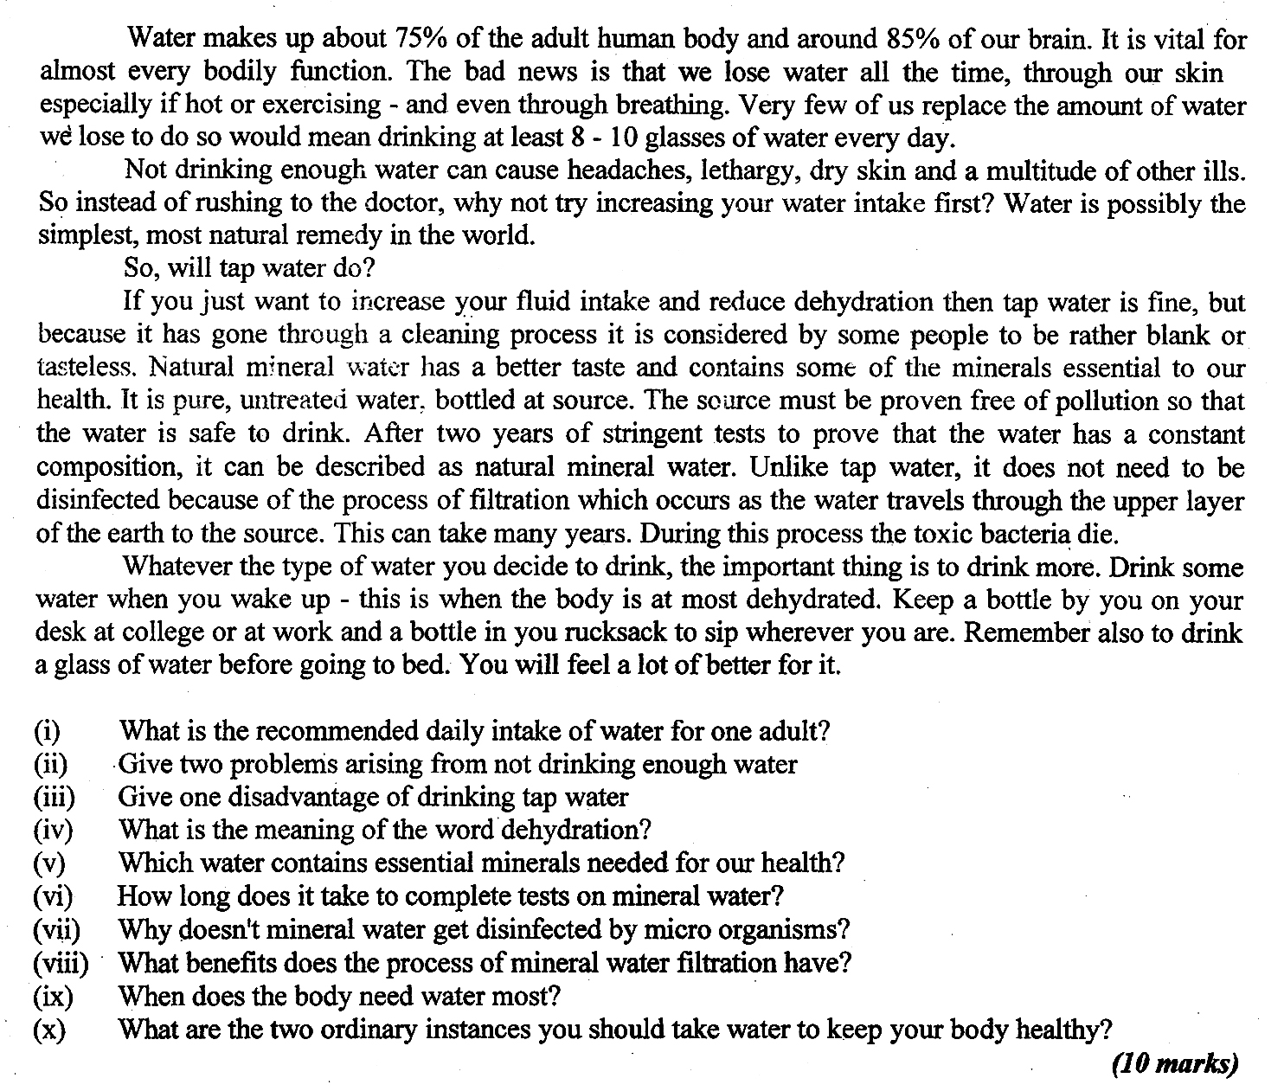

**07. Write a paragraph with the following statement.**

Education knowledge and experiences are constituent parts of a success. **(10 Marks)**